Welcome to Word

5 tips for a simpler way to work

Use live layout and alignment guides
Click the image below and drag it around the page. With images that have text wrapping, the text moves around the picture so you get a live preview of the new layout. Try to line the image up with the top of this paragraph to see how the alignment guides can help you position it on the page. Click the Layout Options button next to the image to change how it interacts with the text. Learn more at office.com
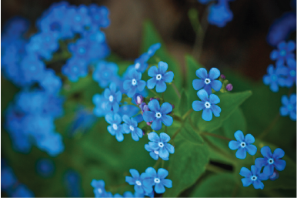

Collaborate in Simple Markup View
The new Simple Markup revision view presents a clean, uncomplicated view of your document, but you still see markers where changes and comments have been made. Click on the vertical bar on the left side of the text to see changes. Or click the comment icon on the right to check out comments about this text.
Learn more at office.com

Insert Online Pictures and Video
Add and play online videos inside your Word documents. Add your pictures from online photo services without having to save them first to your computer. Click Insert > Online Video to add a video to this document.

Enjoy the Read
Use the new Read Mode for a beautiful, distraction-free reading experience. Click View > Read Mode to check it out. While you’re there, try double clicking on a picture to get a closer view. Click outside the image to return to reading.

Edit PDF content in Word
Open PDFs and edit the content in Word. Edit paragraphs, lists, and tables just like familiar Word documents. Take the content and make it look great.
Download this helpful PDF from the Office site to try in Word or pick a PDF file on your computer. In Word, click File > Open and navigate to the PDF. Click Open to edit the content or read it more comfortably using the new Read Mode.

Ready to get started?
We hope you enjoy working in Word 2013!
Sincerely,
The Word Team

Learn More
Keep going. There are lots more new features and ways to work in Office. Check out our Getting started with Word 2013 page online to dive right in.

